
SOEN 6951  Resolute Project | SAD Document

Delivered to: Dr. Olga

DATE | VERSION | DESCRIPTION | Author(s)
28/06/2013 | 1.0 | First draft of this document | Maajid Laali  Keerthika Chakravarthi  Kalyan Nagbandi  Thomas
22/07/2013 | 1.1 | Added the use case, logical view and deployment views for Facebook chat connections and the Chat Analyzing for detecting age. | Maajid Laali  Keerthika Chakravarthi

Table of Contents

1. Introduction 5
1.1 Purpose and goal: 5
1.2 Scope: 5
1.3 Definitions, Acronyms and abbreviations: 5
2. Architectural Representation: 6
3. Architectural Goals And Constraints: 8
3.1 Actor Goal List: 8
4. Use Case View 9
4.1 Sequence Diagram: 10
11
12
5. Logical view: 13
6. Deployment view: 15
7. Process view: 15
8. Implementation view: 15
9. Size and Performance: 15
10. Quality 15
Login 16
Initiating/ retrieving password 17
Connecting to the Social Media (Facebook) and Chat CLIENTS (Skype) 18
Analyzing the chat 19
Creating the user’s account 20
Managing (Remove) the accounts: 21
Detecting distinctive features: 22

Introduction
The pervasive use of internet in day-to-day life has increased and also many new internet communication tools such as social networking (Facebook, Skype) chat rooms, email and instant messaging has been arise. Due to these, kind of social networking websites has put children at potential risk of encountering online predators. This makes predators to take advantage over the use of social environment to build online relationships with inexperienced young people. The main goal of our project is to identify whether a person is a predator or not through analyzing his chat logs. The architecture used for this development is MVC and the framework used is struts.

Purpose and goal:

The purpose of this document is to explain the major components of Resolute with architectural artifacts. With this architecture, we can determine the flow of the system and functionality of each component and the relationships between them.

Scope:

The scope of the architecture artifacts cover the main components of the system.
Use case view
- Actor goal list
- Use cases

Definitions, Acronyms and abbreviations:

The definitions of all terms, acronyms and abbreviations in this document can be found in the appendix attached.

Architectural Representation:
The architecture used for the development is Model View Controller (MVC). Apache Struts is an open-source web application framework for developing Java EE web applications. It uses and extends the Java Servlet API to encourage developers to adopt a model–view–controller (MVC) architecture.

The architecture has multiple views representing the development. The use case view, logical view, Development view, process view and physical view all give a more complete understanding of the system.
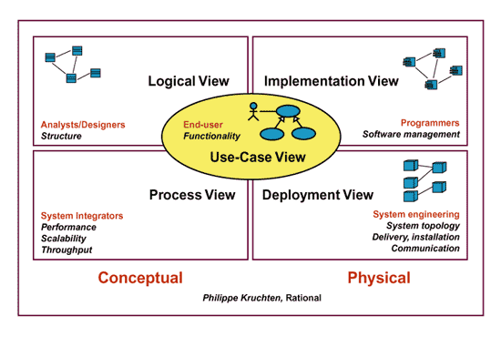
Figure 1 4 +1 Architecture view

The use case view provides the scenarios of the tool developed. It shows the functionality that performed by the system and the end results of the system. Which can help us to the path for creating the system according to the user goals.

The Logical view contains the UML diagrams such as sequence diagram, and communication between the components. In addition, it includes the performance of each component in relation with other components.

The Development view which helps the programmer to find the relationship between the components and their respective activities accordingly.

The Process View contains activity diagrams. The activity diagram represents the flow of activities ad actions that the user encounters to implements a particular user stories. In addition, explains the steps and order of the activities.

The Physical view contains deployment diagram. The deployment diagram represents the physical entities that are used in the Resolute tool and to connect to chat servers. This means that the user who uses our system would need a laptop or PC in provided with an internet connection. Requests are initiated from the users to the server machine through HTTP request and then the server communicates to the database.

4+1 view | Model Elements
Use Case View | Use Case Diagram, Sequence Diagram
Logical View | Package Diagram, Class Diagram
Process View | Activity Diagram
Implementation View/Development View | Component Diagram
Deployment View/Physical view | Deployment Diagram
Table 1 Architecture Model Views

\

Architectural Goals And Constraints:

MVC decouples views and models separately. Therefore:
- Changing of detail implementation of layers (Model or View) does not affect any other. This will help us to work on different parts at the same time.
- MVC allows to attach multiple views to the resolute project without changing the controller layer
- It help to create low-cohesion component, and therefore less effort for maintenance and development.
In Resolute project, Model layer is mostly implemented by GATE platform. The GATE is a platform for creating application for text engineering. We also use MySQL as a database to communicate with WUI and storing needed information.

The Struts Framework helps us to implement the system using the MVC architecture and help programmer to use the API for connecting to chat servers (Facebook, Skype). This also helps us to develop the system faster.

The constraints of system is:
- Learning about MVC
- Learning struts
- Implementation of GATE using struts.

3.1 Actor Goal List:

Actors | Goal
Administrator | Create account  Add or delete account  Update profile
Supervisor | View the chat analysis  View chat reports
User | Connect to chat server  Having a chat conversation with the chat client  Generate a report  Storing information in database  Identifying the predator a known one else a new predator

4. Use Case View

The use case view describes about the actions the users will be performing on the application. It briefly describes about the system functionality as seen by the users. A graphical view of the actors, use cases and their interactions for identifying the online predator is below:

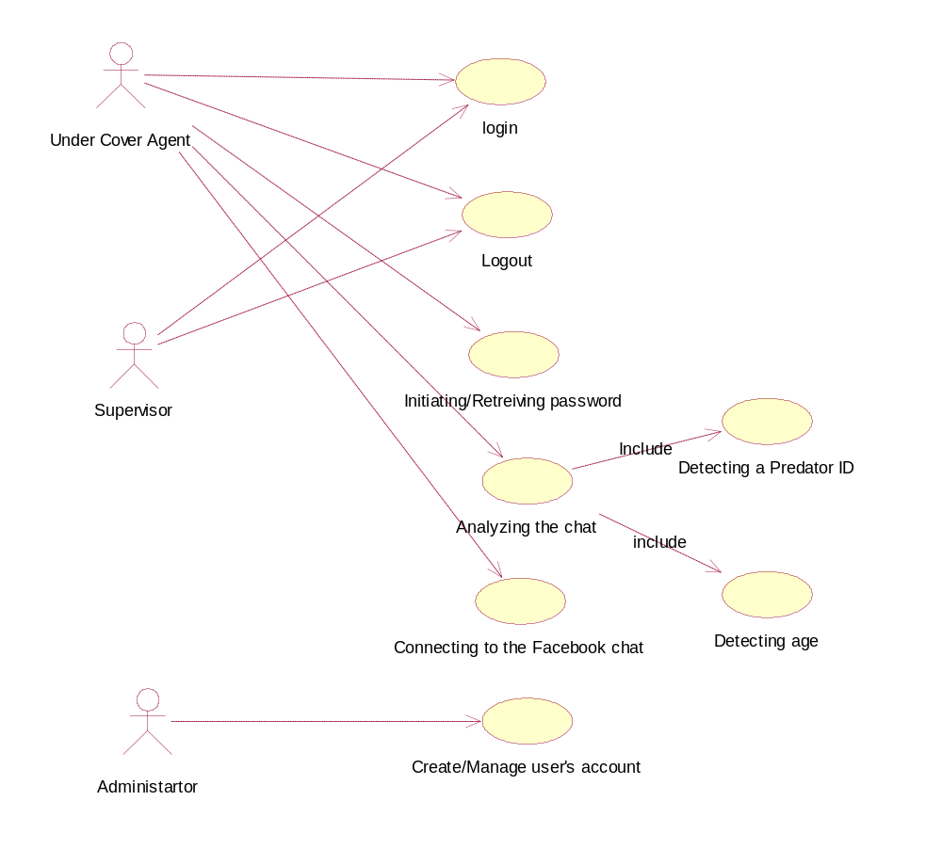
Figure 2Use Case Diagram

5. Logical view:

The logical view describes the functionality of the system provided to the user. The following diagrams are concerned with this view:

Listener Class:

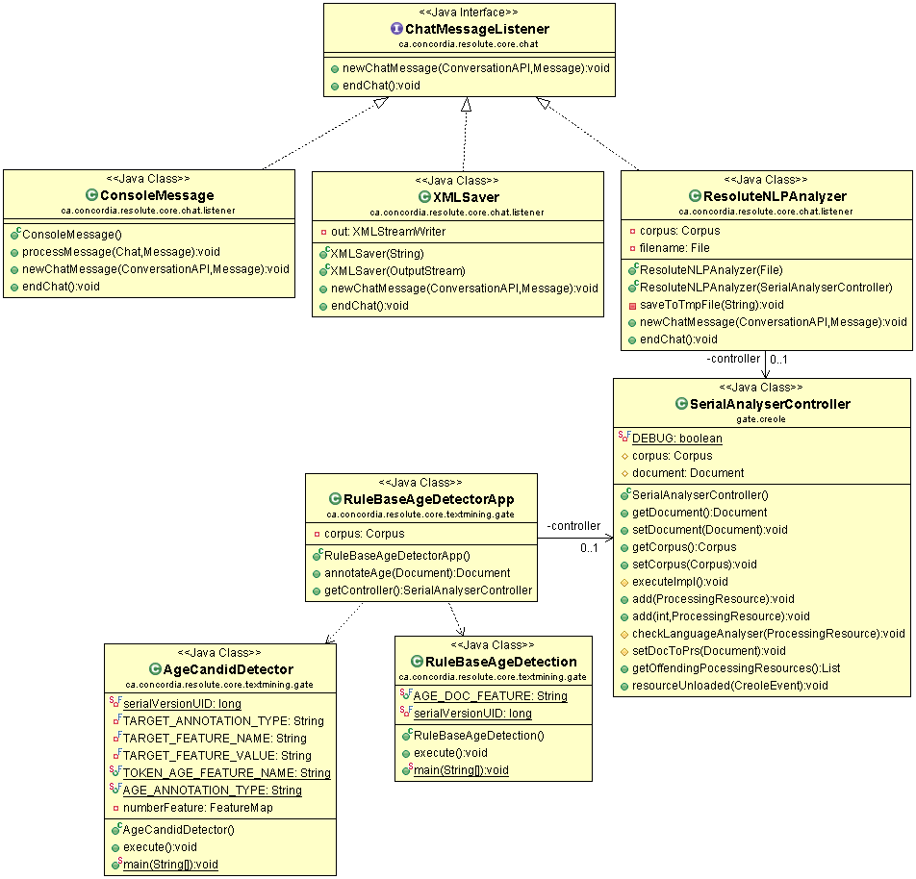

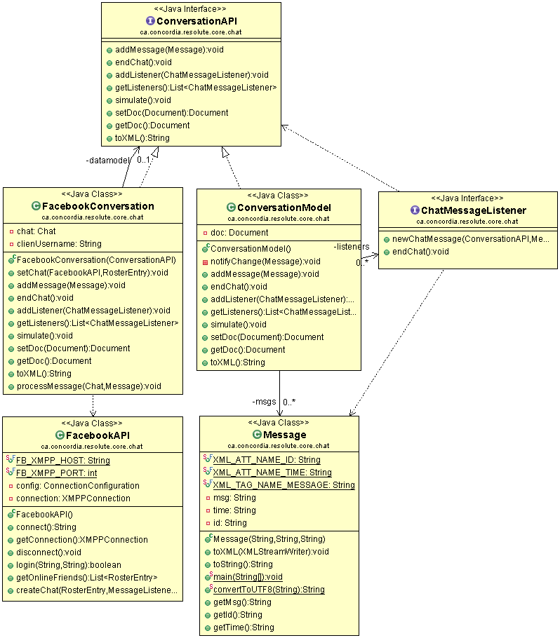

6. Deployment view:

This view is concerned with the system engineers. They are related more to the non-functional requirements regarding the hardware and the organization of the software components in which iCare is to be deployed. This view is illustrated using the deployment diagram.

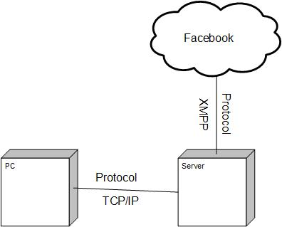

7. Process view:

This view explains about the non-functional requirements such as performance, system availability and fault tolerance. It also explains about the concurrent execution of operations done in the iCare. This is explained using the sequence diagram

4.1 Sequence Diagram:

To describe about the interaction between the users and the application, sequence diagrams are used. It shows the interaction between the objects and classes in a particular scenario. They show the communication between the system and the users.

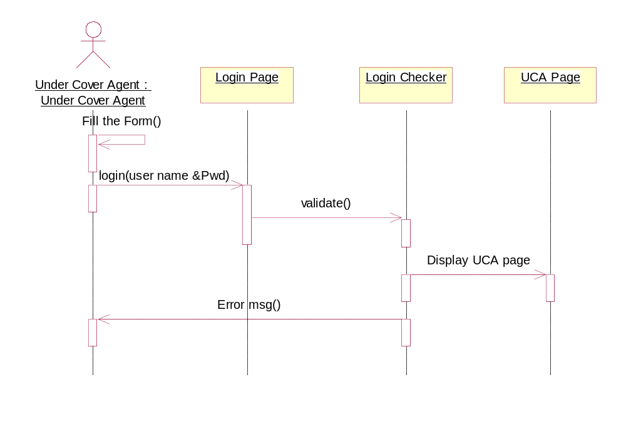
Figure 3 Sequence Diagram-UCA Login

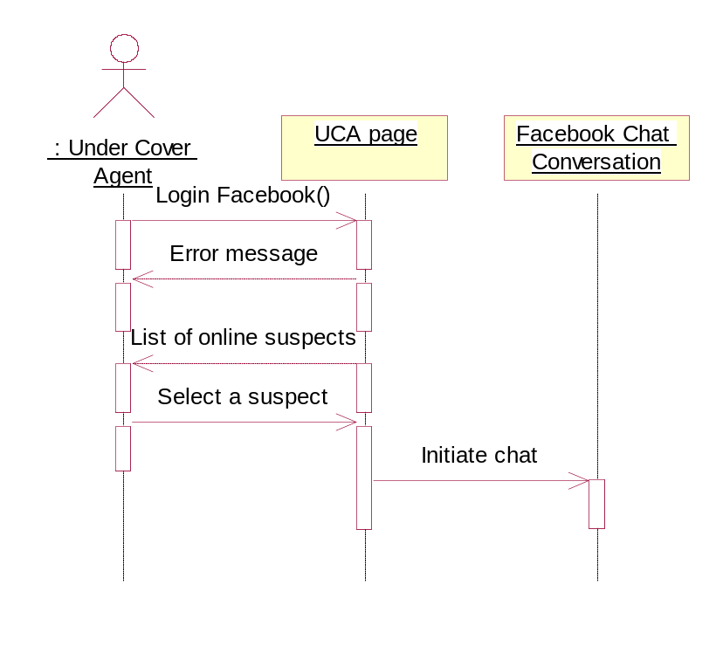
Figure 4 UCA Facebook Login

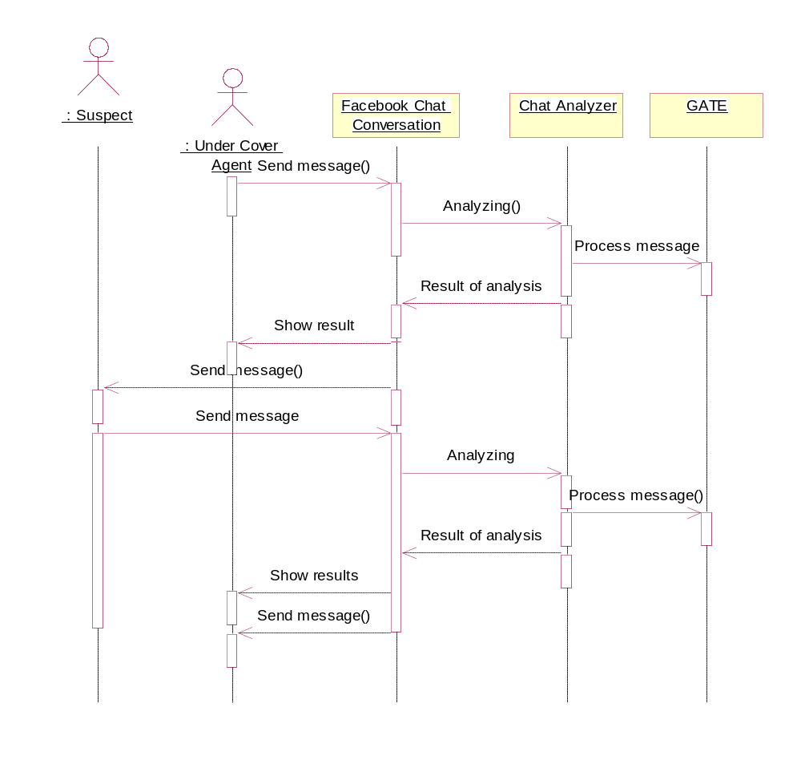
Figure 5 Chat Analysis

8. Implementation view:
This implementation view focuses on the organization of all the software modules into a single package. This view makes the system modules to be developed more easily, to reuse the components and for easy software maintenance. This view also helps in allocating the work among the developers, for estimating the cost and for planning and monitoring the progress of the project. This can be illustrated using the package diagram and component diagram.

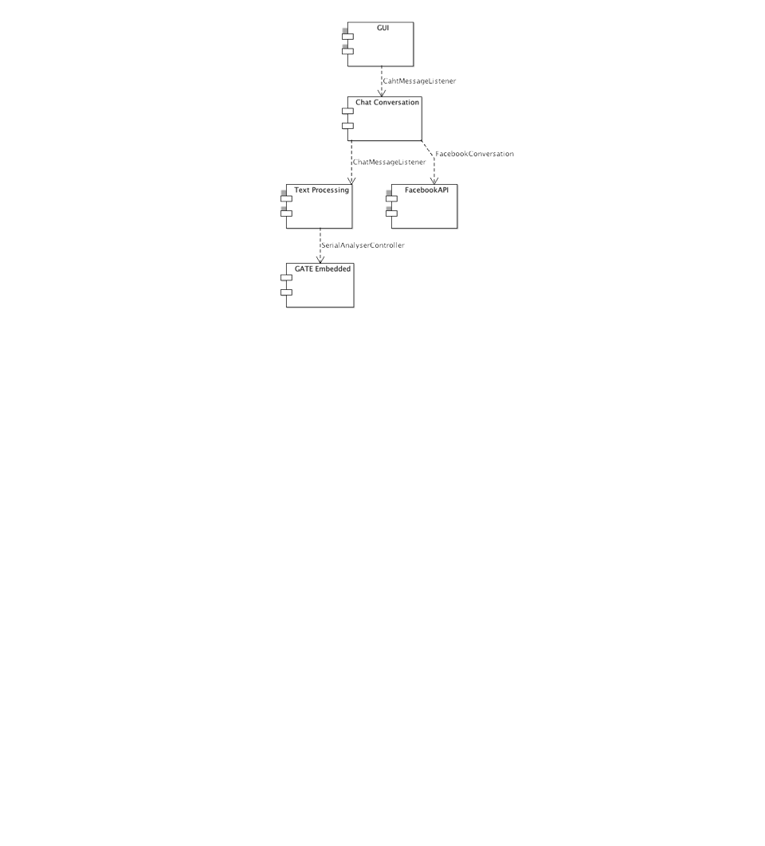

9. Size and Performance:
The Online predator’s application was developed and the architecture was designed by taking into account the features and constraints that was described in the Vision Document.

10. Quality
Most of the quality concerns such as reliability, usability and portability of the system were considered when creating the architecture of the application. To enhance the implementation quality, we used Mccabe to check the quality of the code. Using Mc Cabe, the source code was parsed and the high complexity classes were enhanced.

Login

Reference Number | UC1 | Title | Login Page
Goal in Context | User Authentication before connecting to the application
Scope | WUI | Level | User Level
Priority | Medium
Preconditions | Have a login and password
Trigger | Click Login Button
Post conditions | Redirecting to application.
Success End Condition | The user directed to the application.
Failed End Condition | The user login fails and notifies an alert message
Primary Actor | Admin, Under Cover agent, Supervisor | Secondary Actor | None
Main Success Scenario | - The user enters user name and password  - The system validates the user name and password  - The system connects to the application.
Extensions | 2 a.< validation fails>  1. Validation fails and the user is prompted to retry  2. The system is not connected to the application page  2 b <User request new password>  1. User requests for new password.

Initiating/ retrieving password

Reference Number | UC3 | Title | User requests
Goal in Context | User Authentication fails before connecting to application
Scope | WUI | Level | User Level
Priority | Medium
Preconditions | Invalid User name and password
Trigger | Request from user
Post conditions | New password for user
Success End Condition | The user is provided with a new password.
Failed End Condition | None
Primary Actor | Undercover agent, Supervisor | Secondary Actor | None
Main Success Scenario | - User requests for new password  - System mails the user with a link for resetting his password.  - The user resets his password.
Extensions | None

Connecting to the Social Media (Facebook) and Chat CLIENTS (Skype)

Reference Number | UC4 | Title | Chat server Connection
Goal in Context | Undercover agent connects to chat session
Scope | WUI | Level | User Level
Priority | High
Preconditions | User should be successfully authenticated to the application.  User should have a credential to connect to chat session
Trigger | Click connect Button
Post conditions | System connects to chat session.
Success End Condition | The System connects to chat session.
Failed End Condition | System does not connect to chat session.
Primary Actor | Undercover agent, | Secondary Actor | None
Main Success Scenario | - System provides the available choices for chat sessions.  - User selects one of the chat session  - System connects to the chat session
Extensions | 3.a <Connection fails> system issues the error message  * <User decides to quit>  User logs out of the application.

Analyzing the chat
Reference Number | UC5 | Title | Analyzing the chat
Goal in Context | Undercover agent analyzes the chat logs
Scope | WUI | Level | User Level
Priority | High
Preconditions | User should have the current chat conversations with the client
Trigger | Chat Conversation
Post conditions | Results of the analysis
Success End Condition | None
Failed End Condition | None
Primary Actor | Undercover agent, | Secondary Actor | None
Main Success Scenario | - Users enters the text/ receives the text  - System analyzes the text and saves it in the persistent storage  - repeat steps 1 & 2 until the user disconnects from the chat  - Finally, the system collects the results and send them to the report generator module
Extensions | 2 a.<Detecting distinctive features>  - System detects distinctive features  - System continue from step 1.

Creating the user’s account
Reference Number | UC6 | Title | Creating the user’s account
Goal in Context | Creating a new user account
Scope | WUI | Level | User Level
Priority | Medium
Preconditions | Should have an access to the application
Trigger | Admin requests for a new account
Post conditions | A username and password is provided
Success End Condition | New user account is created
Failed End Condition | Incorrect or incomplete details
Primary Actor | Admin | Secondary Actor | Supervisor, Undercover Agent
Main Success Scenario | - System displays the required forms  - Admin fills the form  - System saves all information  - new user account is created  - system gives an user name and password
Extensions | 2.a <Incomplete details>  1) Incomplete details of a user  2) System informs the admin about the required details  2.b<incorrect details>  1) Admin enters incorrect details of the user(like email, DOB)  2) System informs the admin about the incorrect details  * <User decides to quit>  User logs out of the application.

Managing (Remove) the accounts:
Reference Number | UC7 | Title | Managing the accounts
Goal in Context | Manage the user’s account (Remove)
Scope | WUI | Level | User Level
Priority | Medium
Preconditions | Should have an access to the application
Trigger | Admin request to remove a user account.
Post conditions | Remove the user
Success End Condition | Remove user
Failed End Condition | None
Primary Actor | Admin | Secondary Actor | Supervisor, Undercover Agent
Main Success Scenario | - Admin requests for removing the user account.  - System displays the list of current users  - Admin selects user from list  - System prompts admin for a confirmation  - System removes the user and saves the updated information
Extensions | *<User decides to quit>  User logs out of the application.

Detecting distinctive features:
Reference Number | UC8 | Title | Detects distinctive features
Goal in Context | Detecting red flag from chat conversation
Scope | WUI | Level | User Level
Priority | High
Preconditions | Chat conversation
Trigger | Red flag(offensive language) in chat conversation
Post conditions | Detect red flag
Success End Condition | Detects red flag
Failed End Condition | None
Primary Actor | System | Secondary Actor | Under Cover Agent
Main Success Scenario | - System receives the text  - System analyzes the text  - System detects distinctive features  - System displays distinctive features
Extensions | None

